AS91907 – Use complex processes to develop a digital technologies outcome

Name: Heinrich Venter
Teacher: Mr Sutherland

Outcome Development
Please provide a detailed description of your outcome here. If relevant, provide screenshots of wireframes, brainstorms, and user journeys.

Relevant Implications
Examples are: social ● cultural ● legal ● ethical ● intellectual property ● privacy ● accessibility ● usability ● functionality ● aesthetics ● sustainability and future proofing ● end-user considerations ● health and safety.
Implication | Description of a relevant implication and how it is relevant. | Explain why the implication is important and how you plan to address it. | How you have met the implication.
Accesability |  | It is important because riders need to operate the hybrid system, throttle, and display safely without confusion. I will address this by using clearly labelled switches, simple control layouts, and making sure components like the electric–petrol mode indicator are easy to read. | The way I met this application is by having the entire system understandable in a way that someone who’s never ridden a bike can hop on and be able to understand what’s going on without a lot of explanation and minimal confusion
  Accessibility for the pit bike means the bike’s controls, indicators, and basic functions need to be understandable and manageable for a range of riders. This includes clear visual indicators, easy-to-reach switches, and controls that do not require excessive strength.
Usability | Usability relates to how easy it is to understand and use the pit bike’s hybrid systems, such as switching modes, checking battery levels, or starting the bike. The design needs to feel intuitive even for new riders. | It matters because if the interface is confusing, the rider could misuse the bike or struggle during operation. I will address this by keeping the hybrid controls simple, limiting unnecessary switches, and providing a logical layout like standard pit bikes so it feels familiar. | The way I met this application is by having all the controls connected with the main controls meaning that only the required controls are on the bike and is running in tandem with the engine controls meaning it’s not a maze of controls that need to be done one at a time
functionality |  | It is important because the bike must be reliable and safe. I will address this by testing the hybrid system regularly, checking wiring, ensuring the mechanical and electrical parts don’t interfere with each other, and confirming that power output remains stable. | The way I met this application is by testing all the controls outside to make sure its working and then add them one by one making sure everything still works as I go on
  Functionality refers to how well the 70cc hybrid pit bike performs its intended purpose—delivering reliable petrol and electric operation, smooth power delivery, and stable riding. It also includes ensuring the components (battery, controller, mechanical systems) work together correctly.
Aesthetics | Aesthetics for the pit bike include the visual design—how the hybrid components are integrated, how tidy the wiring is, and the overall look of the bike. A clean, professional aesthetic helps the bike feel intentional rather than thrown together. | It is important because a well-presented bike improves user confidence and makes maintenance easier. I will address this by organising wiring neatly, using matching colours or covers, and ensuring added components blend with the original frame, so the hybrid upgrade looks cohesive. | The way I met this application by having boxes where the electronics are placed into the bike and the wire come cleanly out of them this not only covers up messy wiring but also protect the electronics from the weather

Project Management Techniques
Project Management techniques include:
- Agile, Kanban, or waterfall techniques
- Version control
- Collaboration and communication
- Managing assets
- Code review
- Project Scheduling
NZQA note 1: Student evidence needs to show how the project management tools were used effectively in the development of the outcome. Evidence may include adjustments to timelines and resources. Explanation of how feedback and collaboration tools were used to develop and improve the outcome is required.

Project Management Tool: git hub
Description: | using GitHub that saves every version history so there is a mistake or something that is changed incorrectly you can go back to that specific version
How often did you use it: | Every time I close my files so that it’s saved when I close my laptop/computer and if I need to go back to a previous file that was deleted, I can recover the file without redoing that work all over again
Evidence 1:
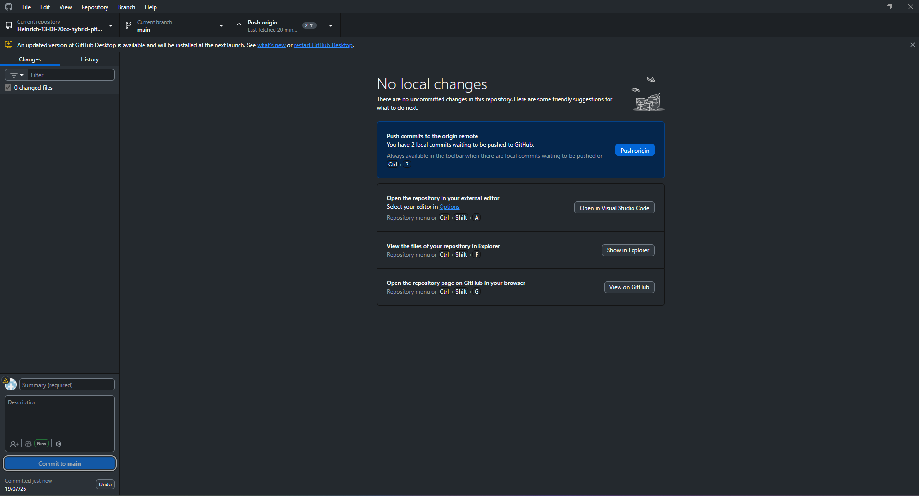
Evidence 2: 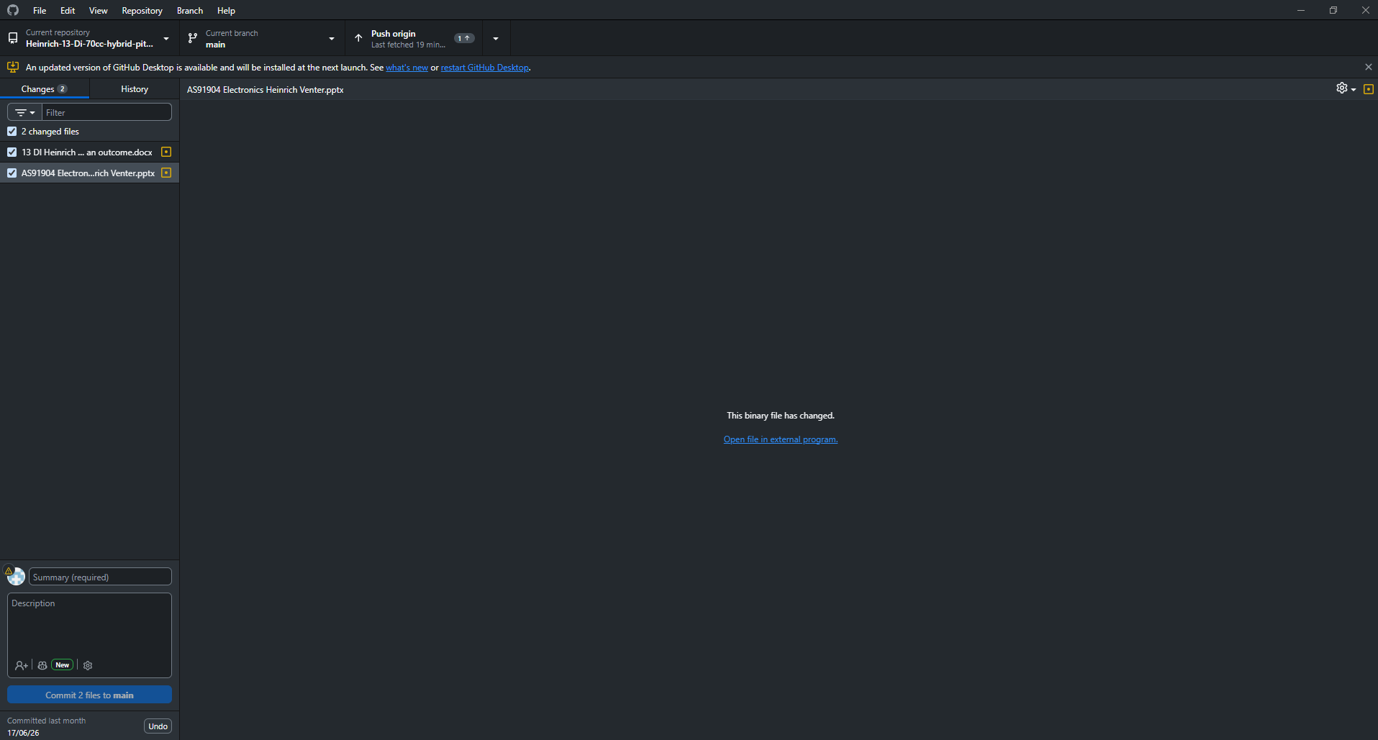
Evidence 3:
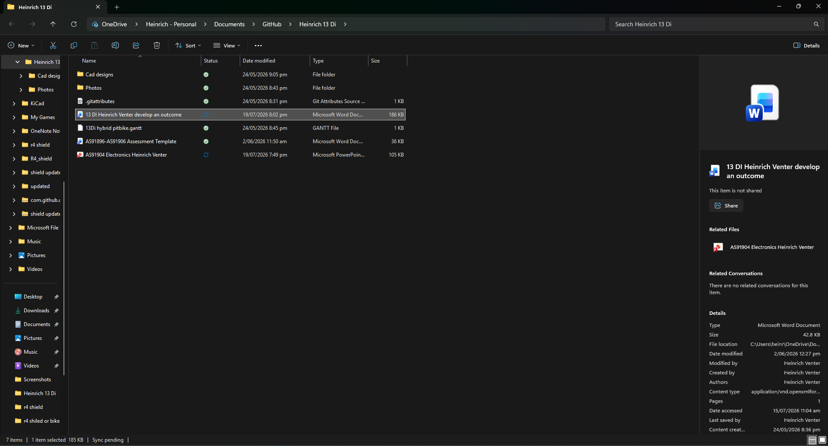

Project Management Tool: Gantt chart
Description: so that you can keep up with your project to see how hard you need to work to get to where you need to be to make a good outcome of your project
How often did you use it: | Every week I check and update the Gantt chart to check weather I’m on schedule falling behind or even in best case scenario ahead of schedule
Evidence 1: 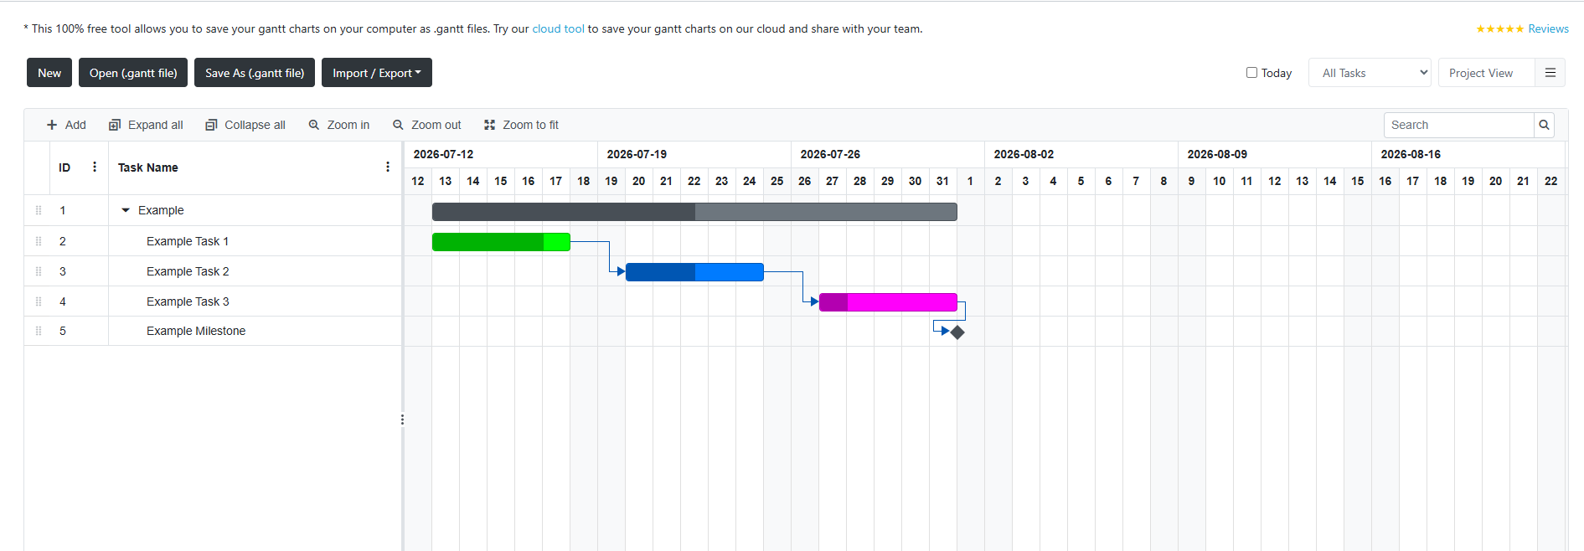
Evidence 2: 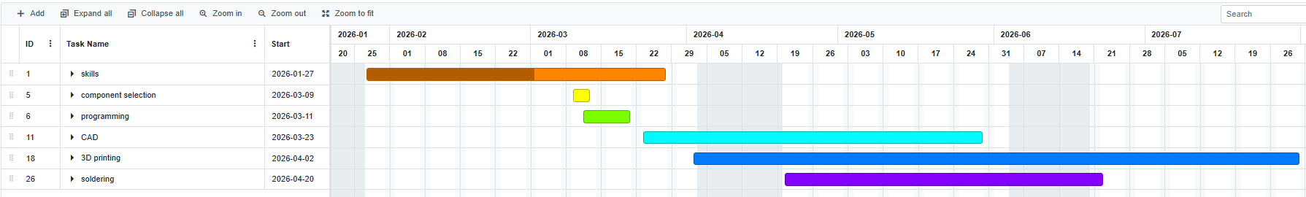
Evidence 3: 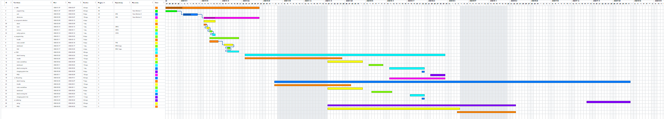

Project Management Tool: GitHub
Description: | Using GitHub Issues to keep track of problems, tasks and improvements that need to be completed during the project. This lets me record what needs to be done and keep track of what has been completed.
How often did you use it | : I used it throughout the project whenever I found a problem, needed to add a new feature or had a task that needed to be completed. I could then mark issues as completed once I had fixed or finished them.
Evidence 1: 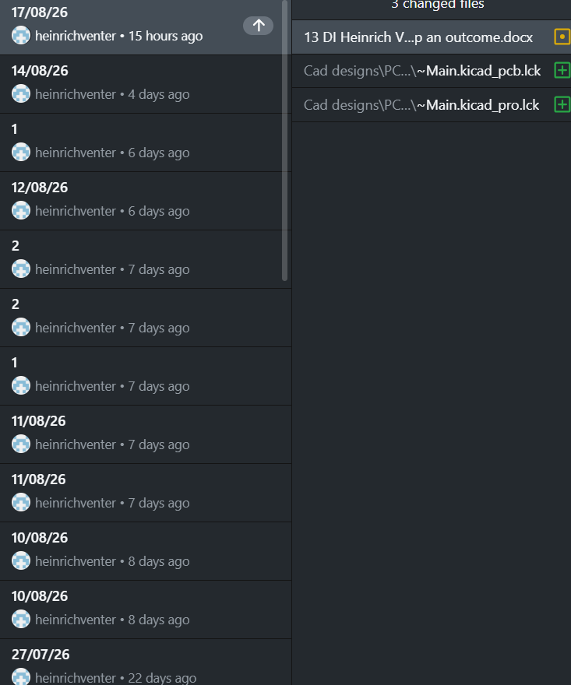
Evidence 2: 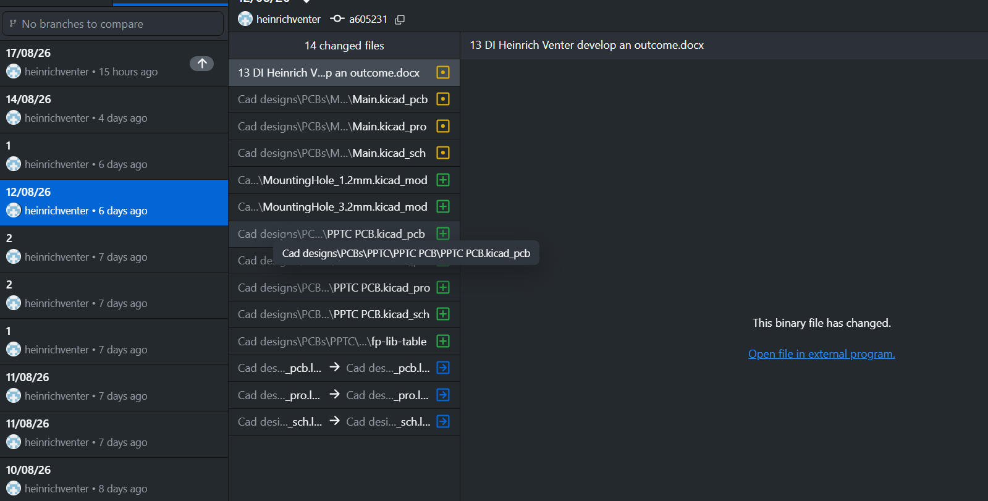
Evidence 3: 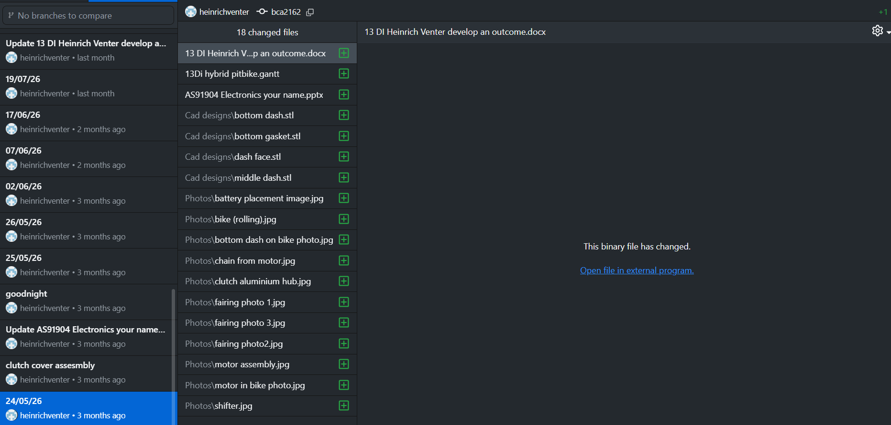

Smaller Components
Break your outcome into smaller components and list them here:
e.g. Storyboard, Intro, Drone footage, interview footage
Component | Description
3d design | Designing the required components holders so that when in use the sensitive electronics doesn’t get damaged or broken and then gives faulty readings to the brain which can affect efficiency and control.
Electronics | Using the right electronics for what I need it to do and figuring out where all the parts need to sit
Easthetics | Designing an aesthetically pleasing system that makes someone go and say “that is cool”

Component Selection

Select a component such has story board, trial different techniques or other components and select which one you will use:
Merit: effectively trialling multiple components and/or techniques

NZQA note 2: For Merit, students should effectively trial multiple components and/or techniques and select the most suitable. Merit does not simply require trialling more components than those needed for Achieved. A student should trial more than one different way to solve the same sub-problem and select the best

Component: clutch
A clutch on the electric motor is needed because of 2 things
1 being that the electric motor only has a rpm limit of 2750 rpm and the 70cc can reach rpm speeds at the drive shaft of up to 4000-5000 rpm which is way higher than the motor can safely handle
2if the motor surpasses its max rpm it will cause something that is called back emf or reverse emf (electromagnetic force) which can cause the system to be braked and can slow you down
Component/Technique | Component/Technique | Component/Technique
Electro magnetic  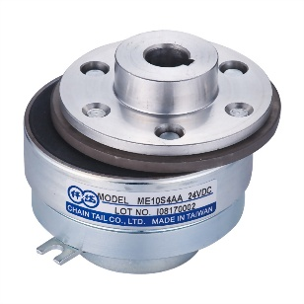 | Centrifugal  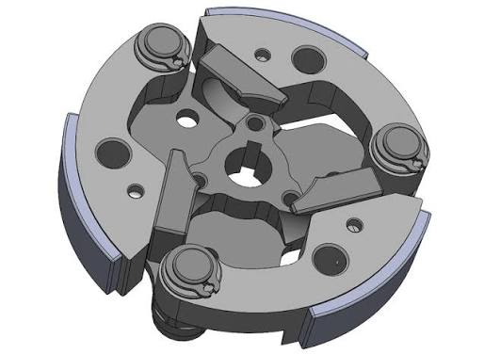 | One way bearing  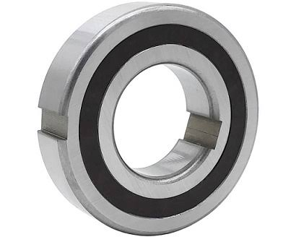
Selected Component: I’m going with electromagnetic
Why: because with an electromagnetic you can have torque and speed from 0rpm where with a centrifugal it needs to be spun to a certain set rpm i.e. 2000 rpm which means ill have about 750 rpm of speed range not including gear ratios for inc4reasinf the torque of the system which means that I’ll have to use the 70cc’s torque which isn’t the greatest and until the engine reaches the range of where the clutch can engage I’ll be able to accelerate an extra 2km/h where with an electromagnetic I can engage from 0rpm and then have a speed range of 2750 from the motor which means ill have a 50km/h range of where it can accelerate with the electric motors torque which is greater at low speeds than the 70cc’s

Component: accelerator
Component/Technique | Component/Technique | Component/Technique
Hall effect sensor  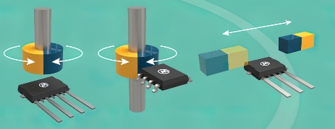 | Potentiometer  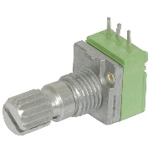
Selected Component: hall effect sensor
Why: because with a potentiometer it is physically being moved which has friction and can wear out where with a hall effect sensor it’s a magnet which isn’t touching anything so no friction, so it lasts way longer.

Component: screen for the display
Component/Technique | Component/Technique | Component/Technique
Oled display  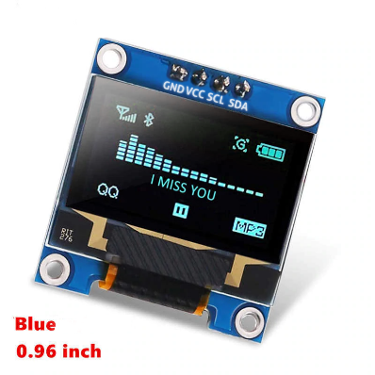 | LCD screen  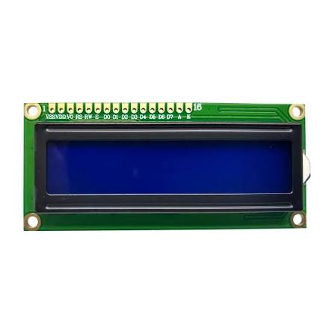 | 1.8” SPI TFT colour display  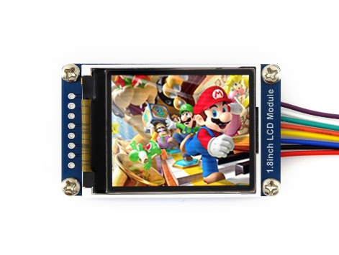
Selected Component: OLED display
Why: The chosen 1.3" I2C OLED display is the optimal choice for this system as it balances pixel-level graphic control (128x64 resolution) with high efficiency, vastly outperforming Alternative 1 (LCD screen), which is limited to rigid character blocks, requires a high-draw backlight, and offers poor viewing angles. Because OLED pixels are self-emissive, unlit black pixels consume zero power, making it ideal for low-power microcontrollers deployment. Additionally, while Alternative 2 (1.8" SPI TFT Color Display) provides vibrant colors, its SPI interface requires 4 to 5 data pins, which limits available inputs and complicates wiring. In contrast, the chosen OLED uses the I2C protocol, requiring only two shared lines (SDA and SCL). This preserves critical GPIO pins for other sensors, simplifies breadboard layout, and ensures a compact, power-efficient, and easily scalable system architecture.

Trialling Multiple Components and/or techniques
List the component, do testing and seek feedback, then make changes to the component, repeat this process 4 times for each component.
Component 1: clutch housing
Component Link/ File Name | Testing/Feedback | Changes to be made
first clutch housing  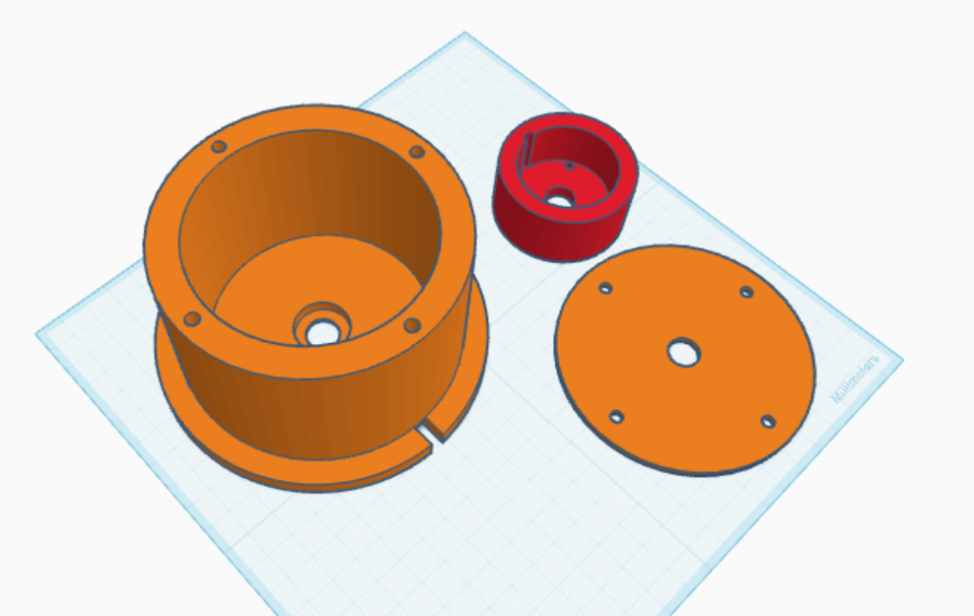 | To small inner diameter make it a larger inner diameter and it’s a good idea to measure the size of your largest component and make the entire thing that size | Inner diameter needs to be bigger for the clutch to fit
second clutch housing  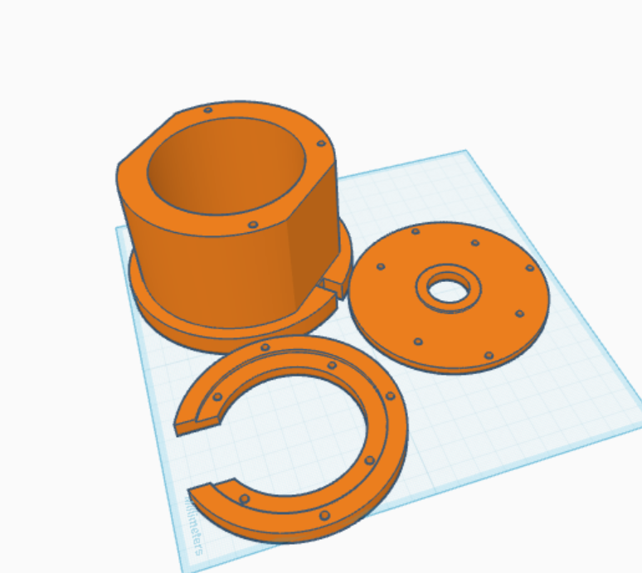 | Too short and the add a slot for the digital hall sensors for the rpm sensing | needs to go from 62.5mm to 65.5mm and slot for digital hall sensors need to be added
third clutch housing  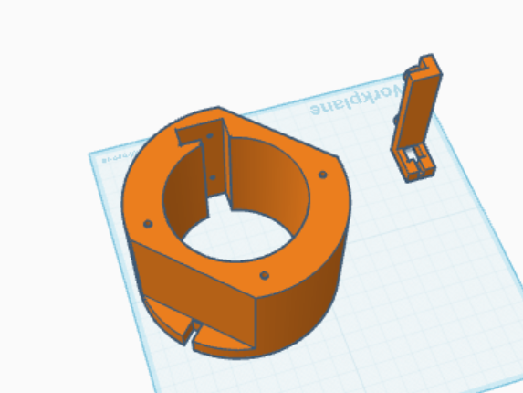 | All good everything works just a note this is plastic parts that are also 3D printed meaning they can very easily snap or tear at the layer lines  Maybe add a metal bracket that attaches to the frame that will be your structural support | Add a metal bracket and high-speed bearing to keep the clutch from getting ripped off the motor

Component 2: throttle
Component Link/ File Name | Testing/Feedback | Changes to be made
first throttle  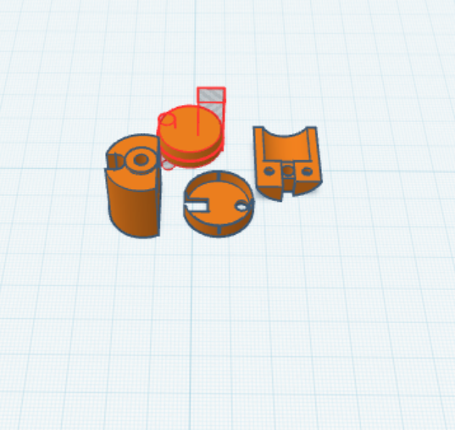 | The stopper is on the wrong side, and the main part is very brittle | Change the side of which the stopper is at and reorientated the main part to be printed stronger
second throttle  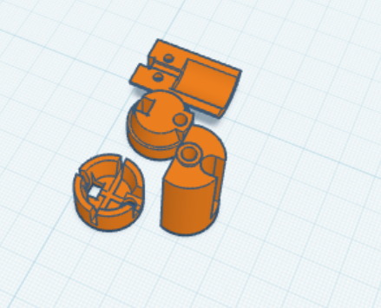 | The pipe is 17mm inner diameter so the outer diameter of the insert should be ≠>17mm, since you’re doing that as well it would be a good idea to make a change to the rubber expander so that it has more surface area to grab onto and easier to expand | Make the diameter smaller for both the rubber and plastic insert, and make the plastic insert taller and the slots to allow it to expand put a small hole on its bottom to make is pivoting point less stiff

Component 3: motor control
Component Link/ File Name | Testing/Feedback | Changes to be made
first motor control hub | The PWM led for the motor controller needs to be 0 when the throttle is at 0 (relative to the analog hall sensors value) this is because the motor controller will take that as an input signal and will engage the motor constantly and it can then be damaged | When the throttle is at position 0 make sure PWM led is0
second motor control hub  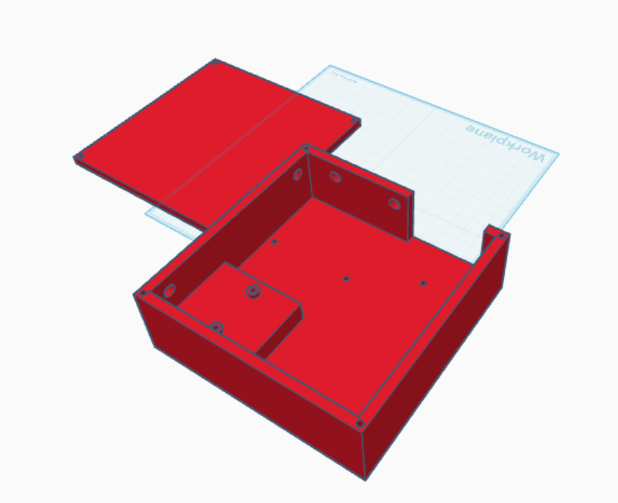 | A good way to show what the motor is behaving like is to have a string of led to show what rpm the motor is spinning at and of course in the app be able to adjust because it can be inaccurate but if you can adjust it, you can adjust how accurate it is | In the app programme make a throttle mapping button to adjust how the motor behaves with the throttle inputs and make sure that it saves so that when you start the bike up again you don’t have to redo the settings (this can be done with eepprom in the programme) also going to be Putting in LEDs and put in programme for LEDs and a way to adjust it also making sure that it saves otherwise it can bog up the system (this can be done through eepprom in the programme).(this will be shown on the dashboard and GUI)

Component 4: dashboard
Component Link/ File Name | Testing/Feedback | Changes to be made
first dashboard  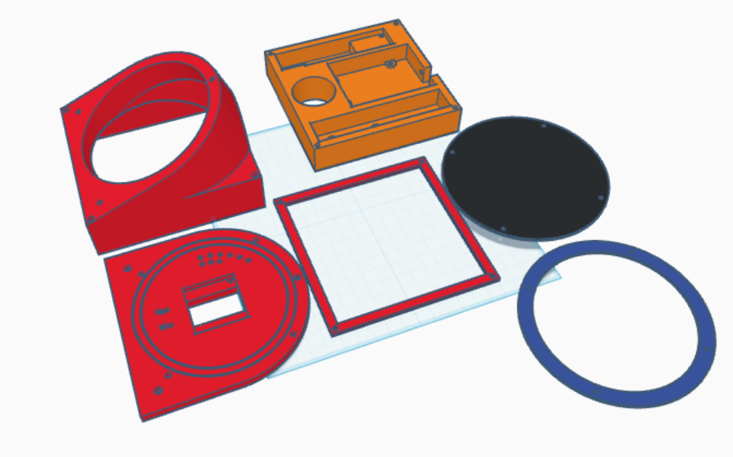 | What if you had the leds on the side of the dashboard in a dial type arrangement | Move the LEDs to the side of the dashboard and have it turn go along with the edge of the dash
Second dashboard  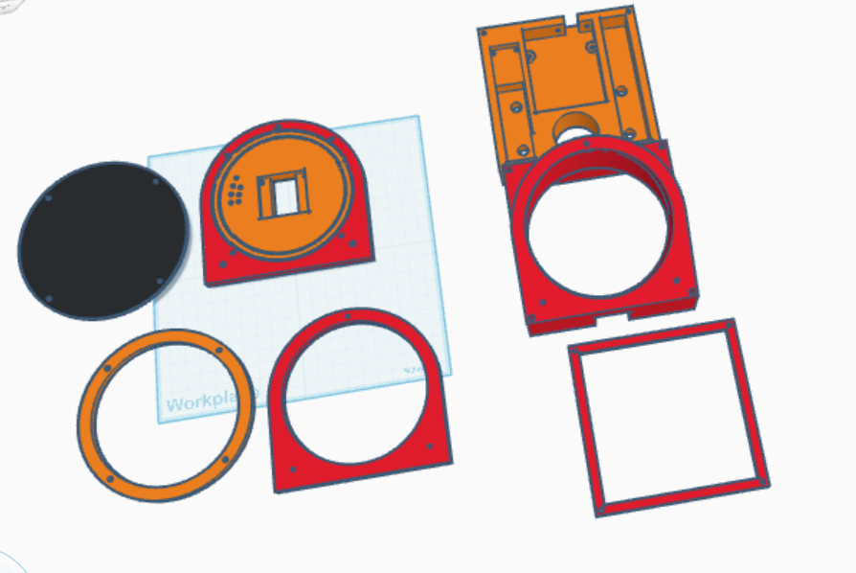 | You will be able to get more sensors into the system if you changed how the LEDs work by making the engine LEDs shine every 2krpm | Take out 2 LEDs and change them to signal ports for sensors
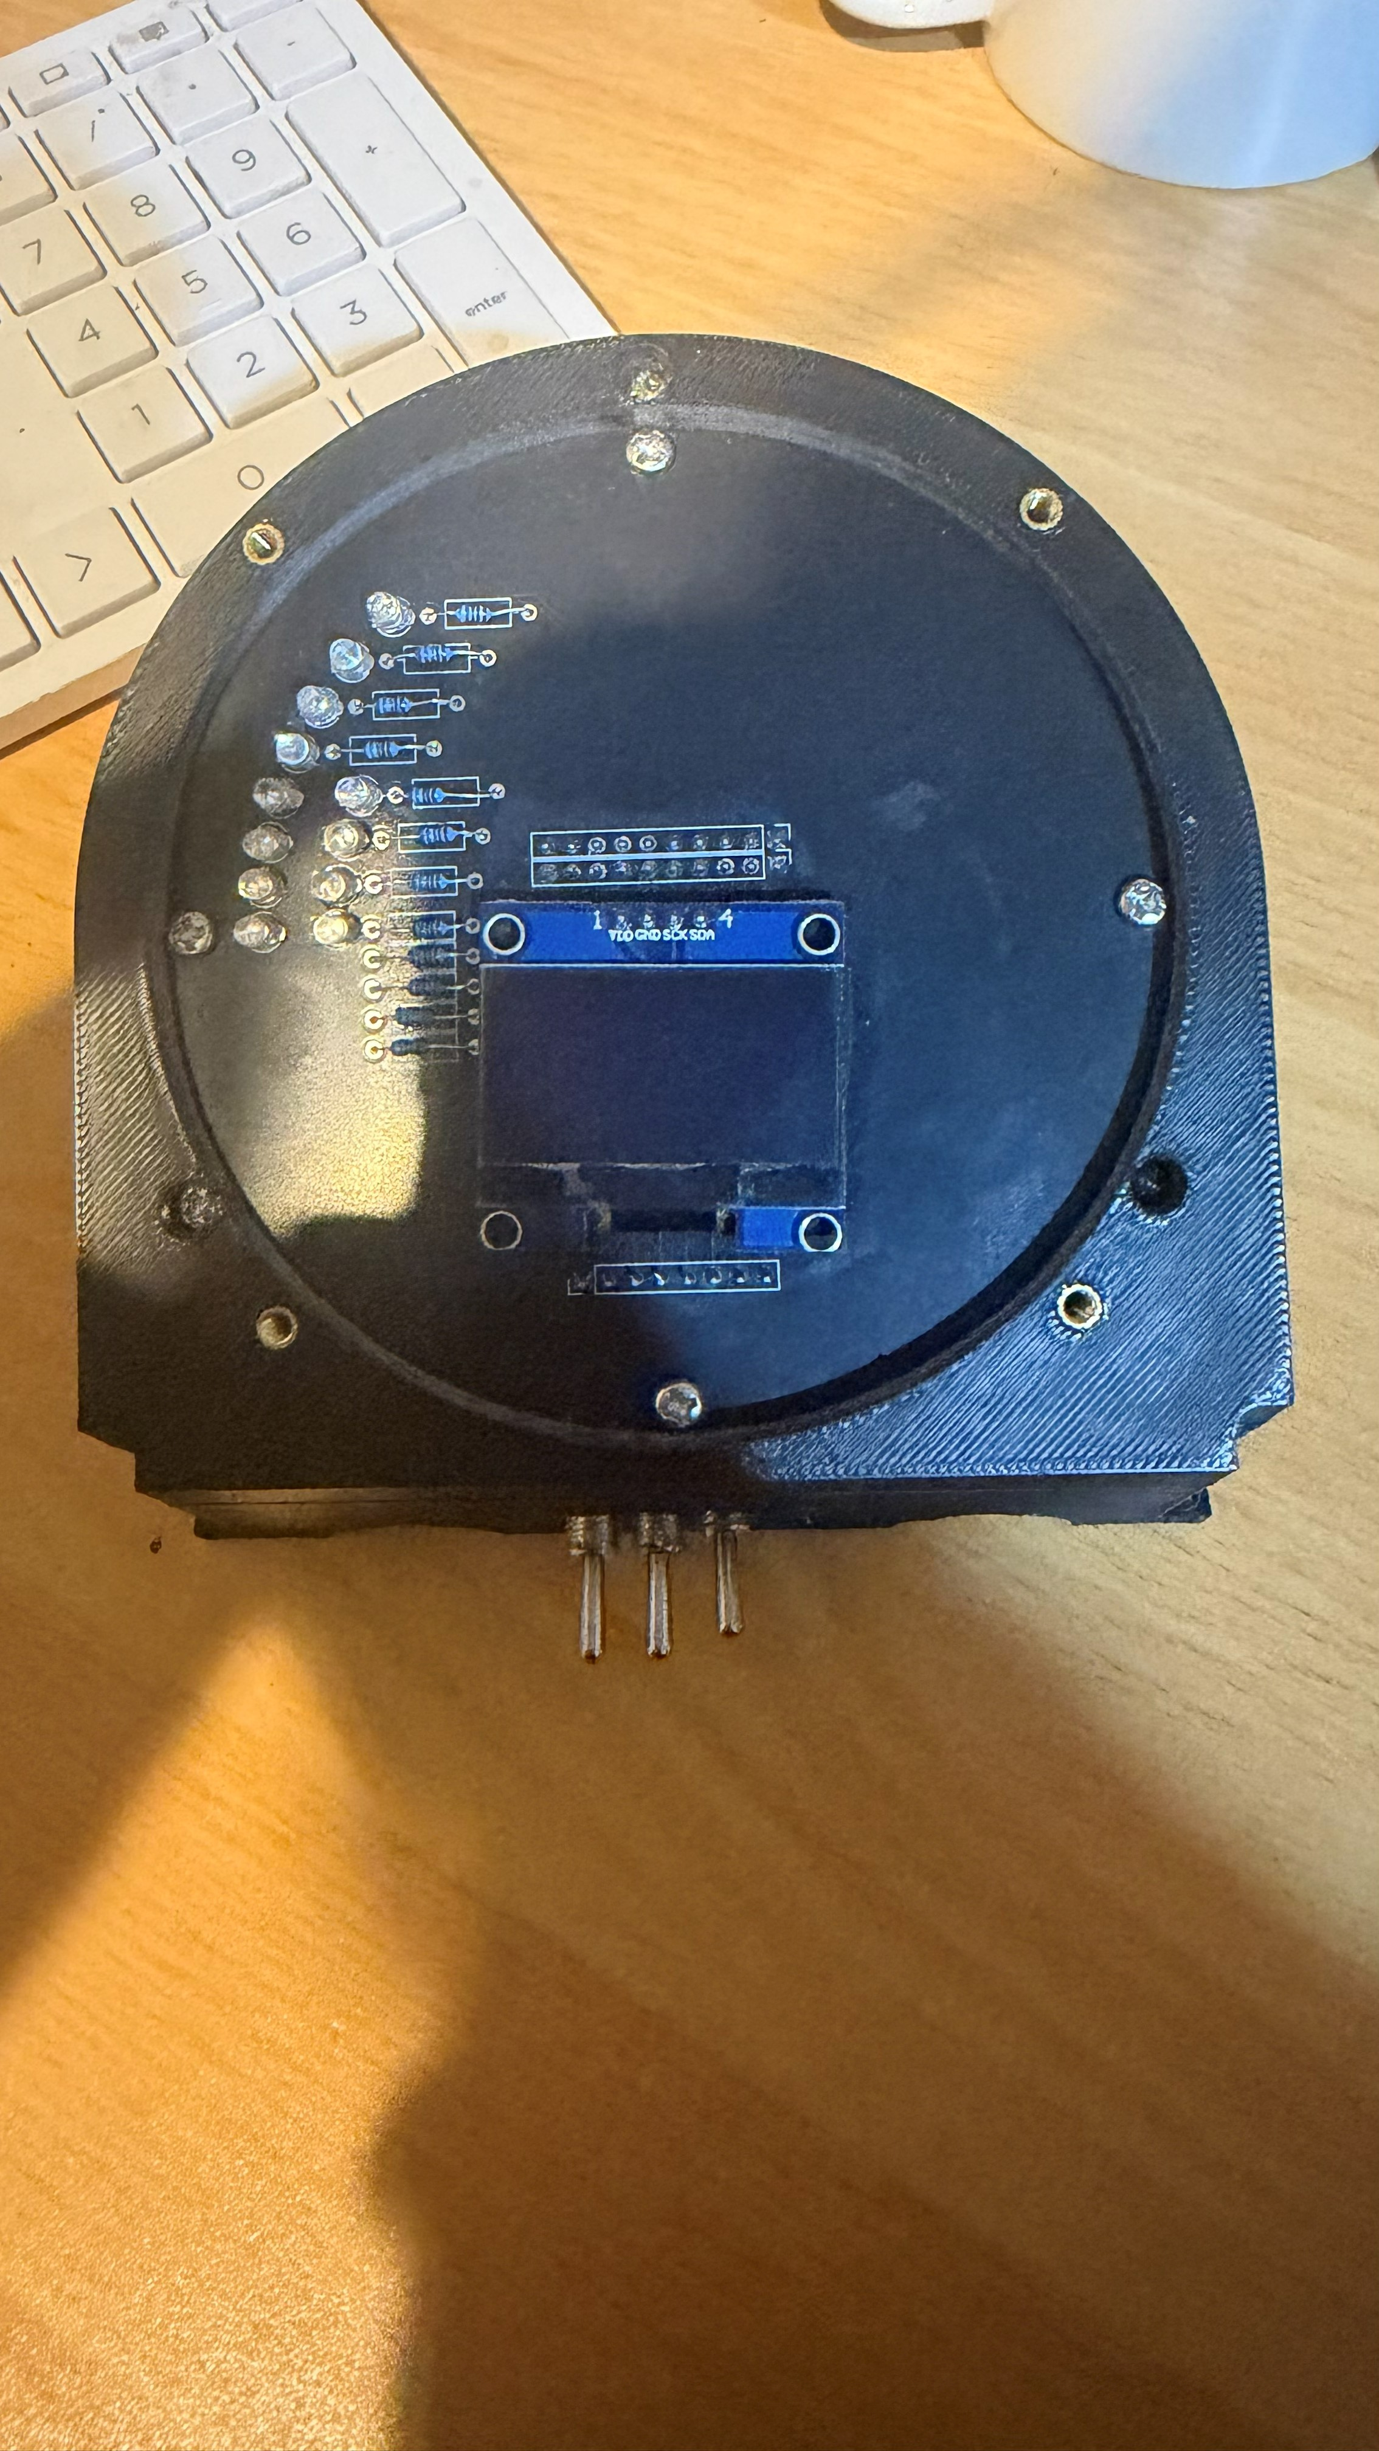 | Wouldn’t it look better if you have a more accurate rpm tracking with a bit more leds so since the engine can spin up to 8000rpm and the motor 3000 make it so that there is more leds, I will also look very nice to have an indication of which gear you are in this can be shown on the Oled display | Add more Leds and in the code add code to see what gear the engine is in

Component 5: PCBs
Component Link/ File Name | Testing/Feedback | Changes to be made
main
dash

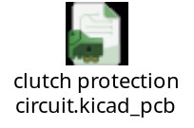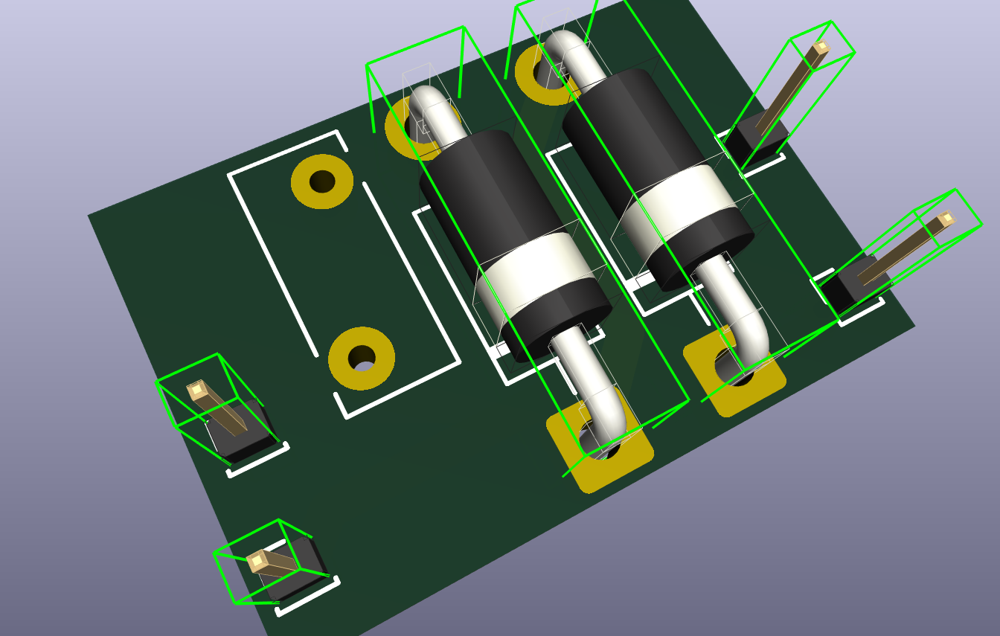 | With testing it has been found that an electromagnet stores a lot of energy and when it gets turned off it gets released very violently (roughly 200V strait back into the system) | A PPTC fuse to protect the magnet, a Zener and Schottky diode will be added onto this PCB to funnel the energy into ground (this bypasses the Mosfet and sensitive low voltage electronics) which then returns it to the batteries
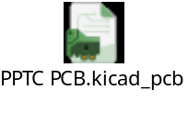  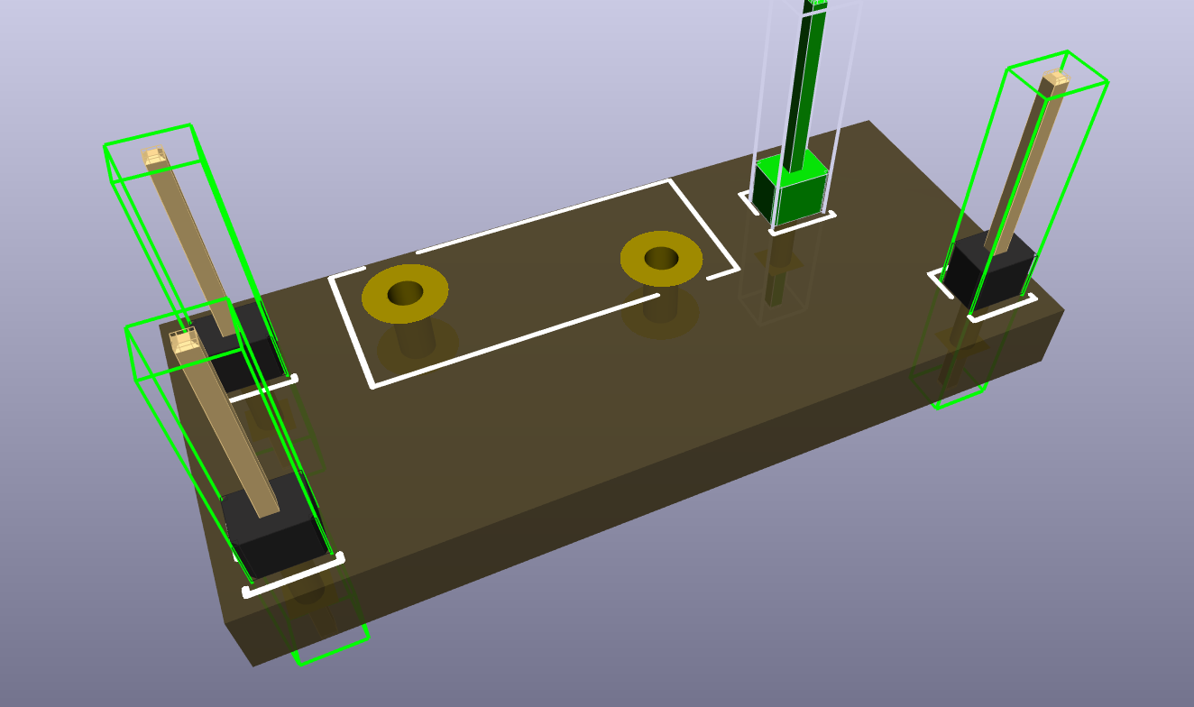 | Alongside the test results of the magnet, it is a good idea to add a fuse to every electronic part so maybe take some PPTC fuses and add them to a small PCB to protect all your parts and not have a fault | In this PCB there will be a PPTC fuse added in series to the Voltage input and at the correct voltage and current rating to protect the parts from voltage and current spikes

Component 8: daughter board
Component Link/ File Name | Testing/Feedback | Changes to be made
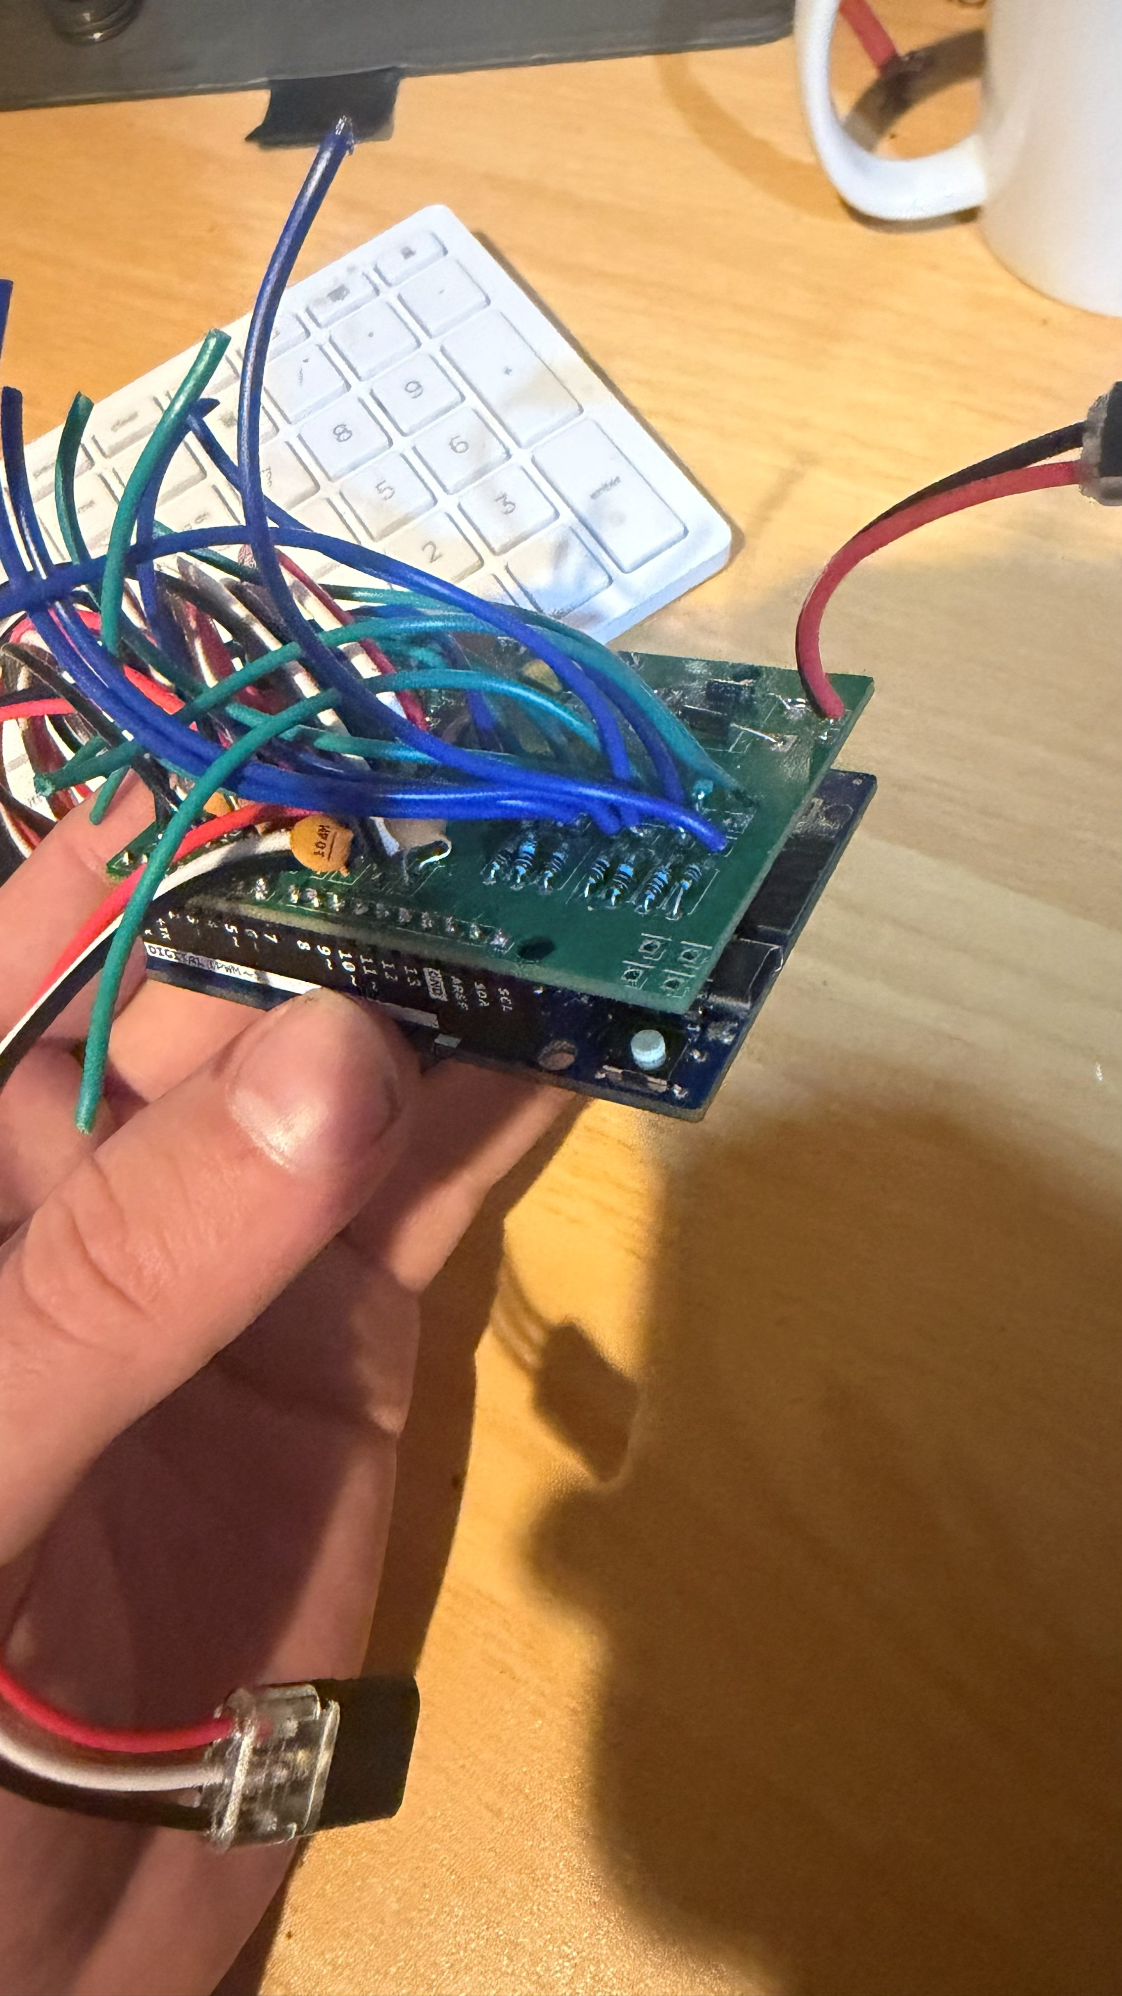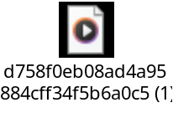 | Is working and was tested but the problem with it is it can blow very easily when connecting components I accidently connected a 24v line to the signal lines and it accidently blew the Arduino r4 Wi-Fi up, Aswell as the buck converter that was originally on it reset and instead of pushing only 12v through it put the full 36v through and the only way the esc would turn on is with 36v so 12v won’t turn it on  Another problem is it costs $62 each | Instead of using a breakout buck converter use a dedicated buck that converts it to only a set voltage and has no potentiometer to change to voltage that can reset the chip
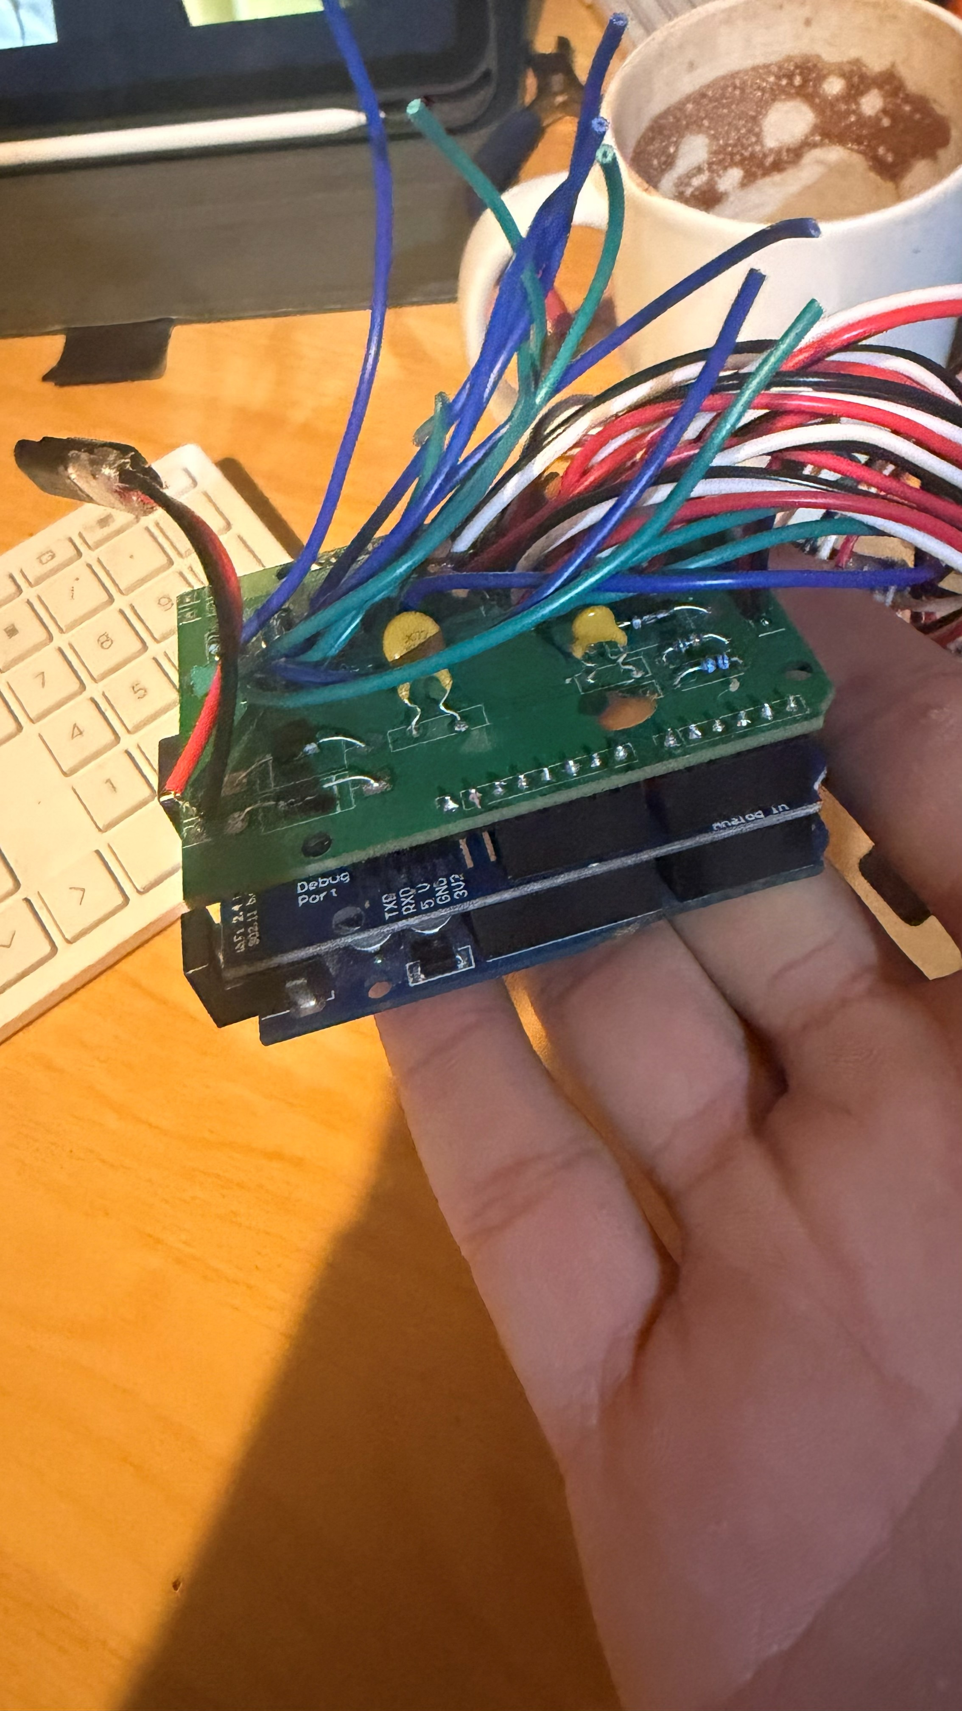 | Using a Wi-Fi shield on the Arduino r3 that has no native Wi-Fi or Bluetooth is a problem because it resets to often due to the shield taking up all the computing power of the Arduino to just start so it’s not a very viable option but for no Wi-Fi it is a viable option  But get feedback form a person at the Uni of Canterbury to replace this with a ESP32 which only cost around $11 each | This is not a viable option and will be going over to an esp32 but if this is being done a new PCB has to be made
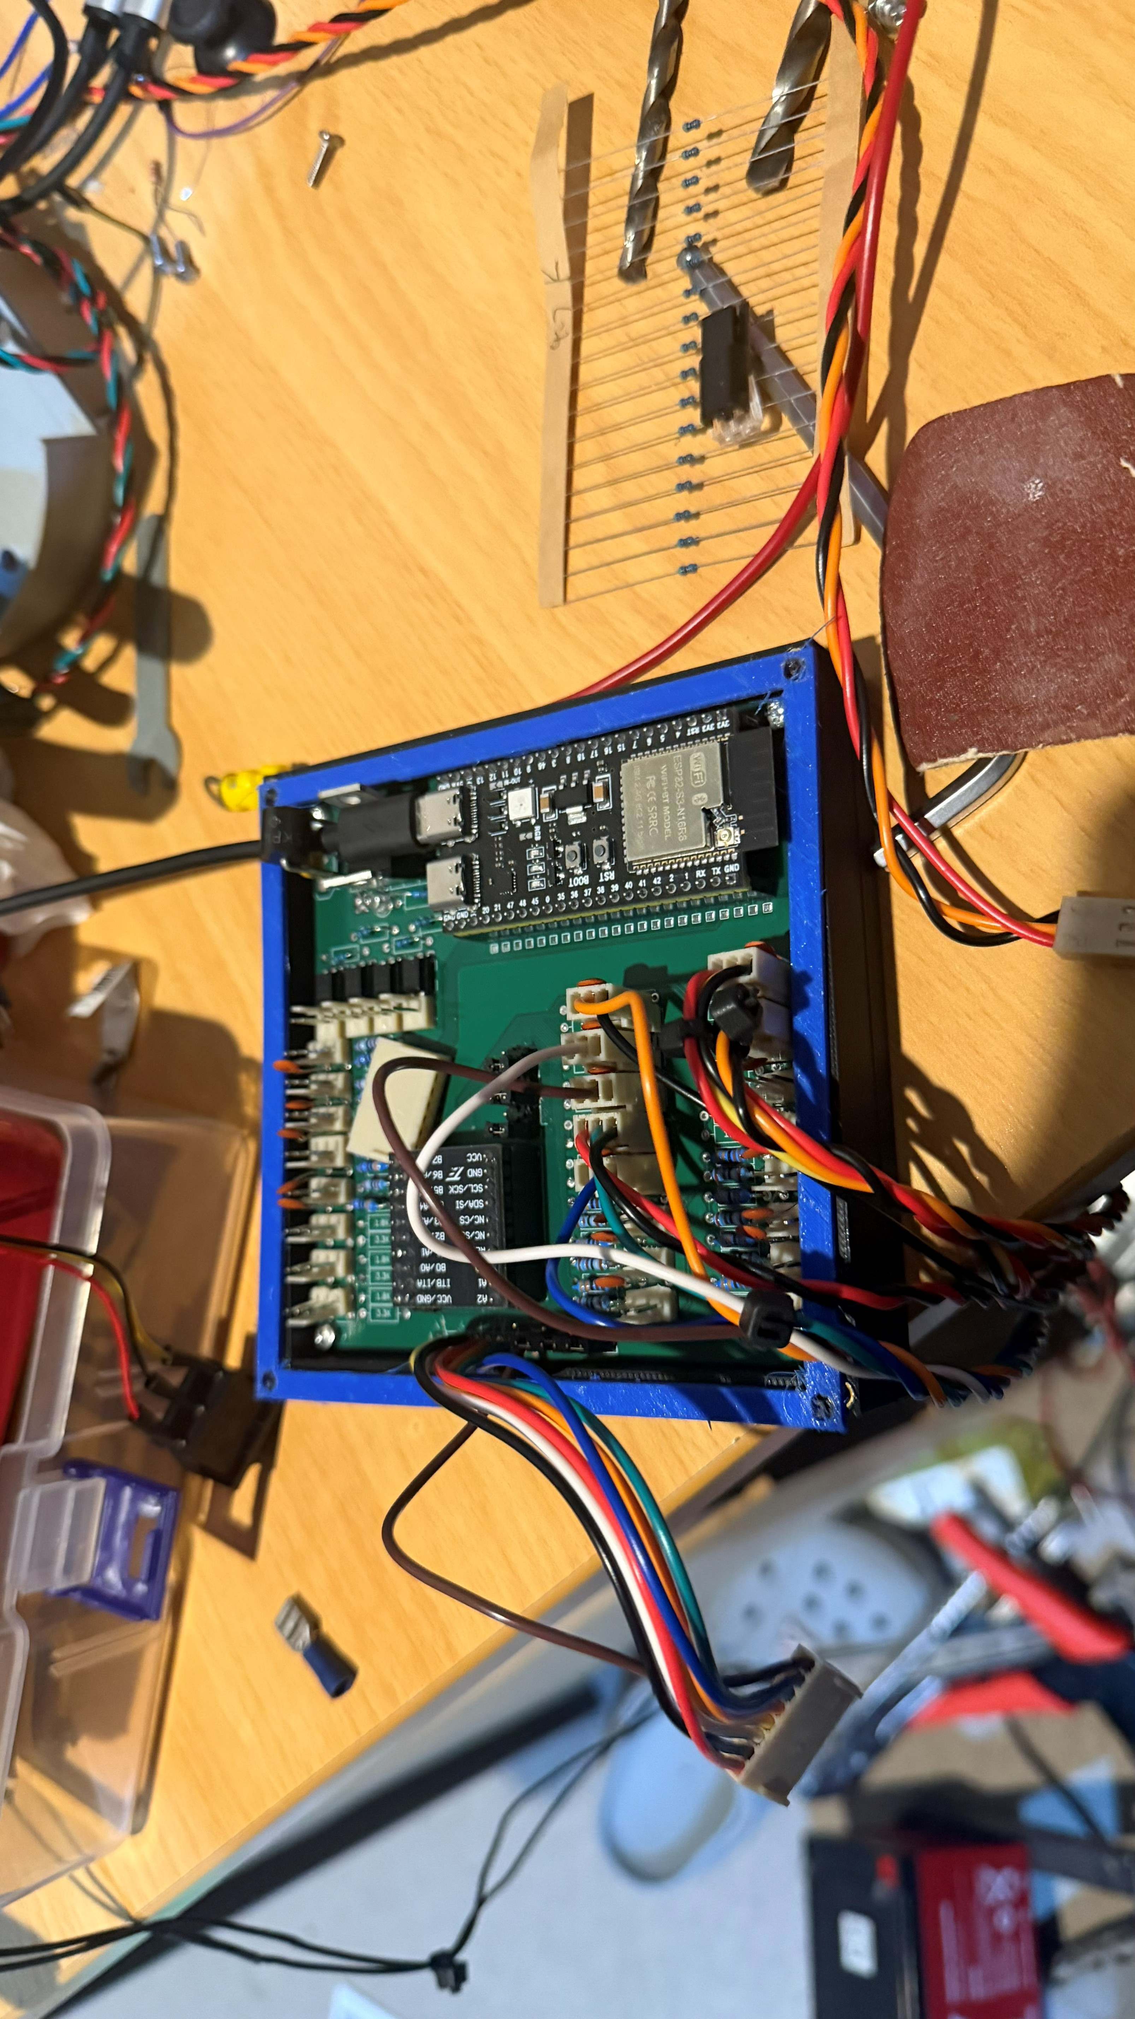  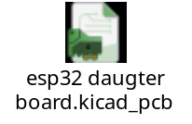  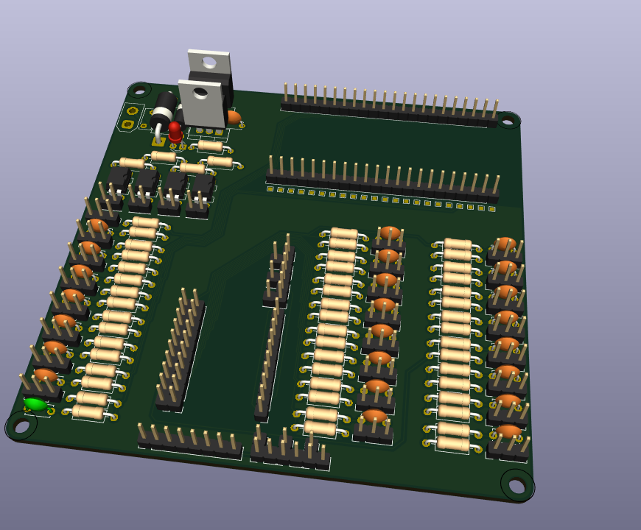 | Since the Esp32 has both Wi-Fi and blue tooth native to its control structure and has 16MB flash memory and 8MB psram (external high speed ram) which is very big for a microcontroller and since the Esp needs to count high speed rpm (8000rpm from the engine) any other Esp will have to work very hard to keep track, since it has this large capacity something like the top speed can be stored like in eepprom so that even if it resets the top speed gets saved  A new PCB was made but some mistakes were made in the design process but thankfully I added enough extra gpio outputs so it is fully operational even with some nonfunctional parts but that can be added to other gpio pins | Where there are nonfunctional parts add it to a breakout perf board with jumper wires, its not pretty but it works

Testing Final Outcome
Please provide a link or location to your final outcome before testing here:

Testing
Test | Description | Changes to be made
Spelling Errors: | Are there any spelling mistakes that were made | Make sure all spelling is correct
Grammar Errors: | Are there any grammar mistakes in what I wrote | Make sure all grammar is correct on my website
Credits: | Who gave help through the development of the project | Make sure all the people that helped through the development of the project gets credited for their work
Audio problems: | NA | NA
Video problems: | NA | NA
Understandable: | Is what I’m conveying understandable to a person who know nothing of what I’m making and how easy is It for them to read this text and see what is going on in a very easy way | Make changes to that a person who’s never heard any of this can understand
Aesthetics: | Is the way that the outcome looks aesthetically pleasing | Make sure it is
Culturally/socially  appropriate: | ?

Final Outcome after Testing
Please provide a link to your final outcome after testing has been completed.

Include a couple of statements supporting how the functionality has been improved due to testing and trialling:
Testing and trialling were a big part of developing my outcome because a lot of the problems were only found once the system was being used on the bike. One of the biggest problems we found was with the electromagnetic clutch. When testing the clutch, it worked normally while powered, but when it was switched off, the electromagnet released a large voltage back into the system. We measured this voltage and found that the spike was much higher than what the ESP and other electronics could handle. This voltage travelled back through the circuit and ended up damaging and frying parts of the electronics. From this testing, I found that the clutch needed its own protection, so I added a Schottky diode across the clutch coil and a PPTC to add extra protection to the circuit. After testing the clutch again, the voltage spike was controlled, and the electronics were no longer being damaged.
Testing the ESP32 and throttle also showed some problems. When the 800 W motor was running, the high current being drawn by the motor created electrical noise and voltage fluctuations in the system. This caused the Hall sensor used for the throttle to give unstable readings, which could make the motor response inconsistent. I added 0.1 uF capacitors to the sensor signal and other sensitive circuits to help filter out the electrical noise. After testing this again, the throttle readings became much more stable and the motor responded more consistently to the throttle input. I also improved the throttle mapping in the ESP32 so the throttle could be adjusted and calibrated rather than relying on one fixed range.
The Hall sensors used for measuring the motor RPM, driveshaft RPM and speed also had issues during early testing. Electrical interference from the motor caused false triggers, which gave incorrect RPM and speed readings. Adding the 0.1 uF capacitors helped smooth the signals and stopped the false triggers. I also planned for shielded and twisted-pair wiring to further reduce interference. This improved the accuracy and reliability of the speed and RPM information shown on the dashboard and OLED.
Overall, testing and trialling helped me find problems that I would not have noticed just from designing the system on paper. Each problem gave me information that I could use to change the design. The outcome was improved through changes such as the clutch voltage protection, PPTCs, throttle filtering and mapping, Hall sensor filtering and battery voltage sensing. This made the digital system more reliable, protected the ESP32 and other components, and made the information and controls more consistent when the bike was being operated.

Final Analysis:

Synthesis of information:
synthesising information gained from the planning, testing and trialling of components

Paragraph 1 – Planning
When planning my outcome, I first looked at what the system needed to be able to do and how all the different parts would work together. I decided to use the ESP32 as the main controller because it could take the different sensor inputs and control the outputs needed for the bike. I planned for it to read the throttle and clutch Hall sensors, measure the motor and driveshaft RPM, monitor the battery voltage and control the electromagnetic clutch. I also planned to have an OLED and a larger GUI dashboard so information such as throttle position, speed, RPM and battery level could be viewed while the bike was running. I also planned protection for the electronics because the bike was using a 36 V battery and an 800 W motor. This planning gave me a basic structure for how the digital system would work and what components I needed to connect.
Paragraph 2 – Testing
Testing showed me that some parts of my original plan did not work as well as I expected. When the ESP32 and 800 W motor were tested together, the motor created electrical noise and voltage fluctuations which affected the Hall sensors. The throttle readings could become unstable, and the RPM sensors sometimes gave false readings. I also tested the battery voltage sensing to make sure the 36 V battery could be safely measured by theESP32. One of the biggest problems was found when testing the electromagnetic clutch. When the electromagnet was switched off, it released a large voltage back into the system. We measured this voltage and found that it was high enough to damage and eventually fry parts of the electronics. These tests showed that the original circuits needed more filtering and protection before they could be used reliably on the bike.
Paragraph 3 – Trialling
After finding these problems, I trialled different changes to see what improved the system. I added 0.1 µF capacitors to the Hall sensor and signal circuits to reduce the electrical noise. After testing them again, the throttle, speed and RPM readings were much more stable, and the false triggers were reduced. I also added a Schottky diode across the electromagnetic clutch and a PPTC to give the circuit more protection from the voltage released when the electromagnet switched off. The clutch could then be operated without damaging the other electronics.
Another important part of trialling was the GUI. Instead of having the throttle mapping fixed in the ESP32 code, I made the GUI allow the throttle minimum and maximum values to be changed. This meant I could test the throttle on the actual bike and adjust the mapping if the throttle was not responding correctly. I also added settings for things such as the clutch threshold. This made the system easier to calibrate because I did not have to keep changing theESP32 code every time I wanted to adjust the throttle response. Trialling the GUI and the physical throttle together helped me get a more consistent response from the motor and made the final system more adjustable.
Paragraph 4 – Combining the Synthesis Conclusions
Looking at the planning, testing and trialling together shows how the outcome developed over time. The planning gave me the basic idea of what the system needed to do, while testing showed me where the original design had problems. Trialling then allowed me to make changes and see if they fixed those problems. For example, I planned to use Hall sensors for the throttle and RPM, but testing showed that electrical noise was affecting them. This led to adding capacitors and improving the filtering. The clutch was also planned to be controlled electronically, but testing showed that the electromagnet was sending a damaging voltage back into the system. This led to adding the diode and PPTC. The GUI was then used to make the throttle system easier to adjust after trialling it on the bike. This shows that information from each stage was used to improve the next stage instead of just following the original plan.

Discussion of this information

Paragraph 5
Using the information from planning, testing and trialling helped me develop a higher quality digital outcome because I could make changes based on what was happening instead of what I expected to happen. One example was the throttle system. I originally planned for the ESP32 to read the Hall sensor and control the motor, but testing showed that the readings were being affected by electrical noise. I added 0.1 µF capacitors and improved the filtering, which made the readings more stable. I then used the GUI to adjust the minimum and maximum throttle values while testing the bike. This meant the throttle could be calibrated to the actual sensor instead of relying on values that were only calculated during the planning stage. These changes made the throttle response more consistent and gave me more control over how the system operated.
Paragraph 6
The same process improved the reliability of the rest of the digital system. Testing the electromagnetic clutch showed that switching the electromagnet off caused a large voltage spike which damaged the electronics. This led to the Schottky diode and PPTC being added to protect the circuit. Testing the Hall sensors also showed that electrical interference could cause false readings, which led to the addition of filtering capacitors. The battery voltage sensing was also developed so that the 36 V battery could be safely measured by the ESP32 and used to provide battery information on the dashboard. These changes all came from information collected during the development process. Overall, planning gave me the starting design, testing showed me what needed to change, and trialling allowed me to check those changes. This helped me produce a final digital outcome that was more reliable, easier to adjust and worked better under the actual conditions of the bike.

